### Initial Scenario

Map of the road and the initial location prediction

We know a little bit about the map of the road that our car is on (pictured above). We also have an initial GPS measurement; the GPS signal says the car is at the red dot. However, this GPS measurement is inaccurate up to about 5 meters. So, the vehicle could be located anywhere within a 5m radius circle around the dot.

### Sensors

Then we gather data from the car's sensors. Self-driving cars mainly use three types of sensors to observe the world:

* Camera, which records video,
* Lidar, which is a light-based sensor, and
* Radar, which uses radio waves.

All of these sensors detect surrounding objects and scenery.

Autonomous cars also have lots of internal sensors that measure things like the speed and direction of the car's movement, the orientation of its wheels, and even the internal temperature of the car!

### Sensor Measurements

Suppose that our sensors detect some details about the terrain and the way our car is moving, specifically:

* The car could be anywhere within the GPS 5m radius circle,
* The car is moving upwards on this road,
* There is a tree to the left of our car, and
* The car’s wheels are pointing to the right.

Knowing only these sensor measurements, examine the map below and answer the following quiz question.

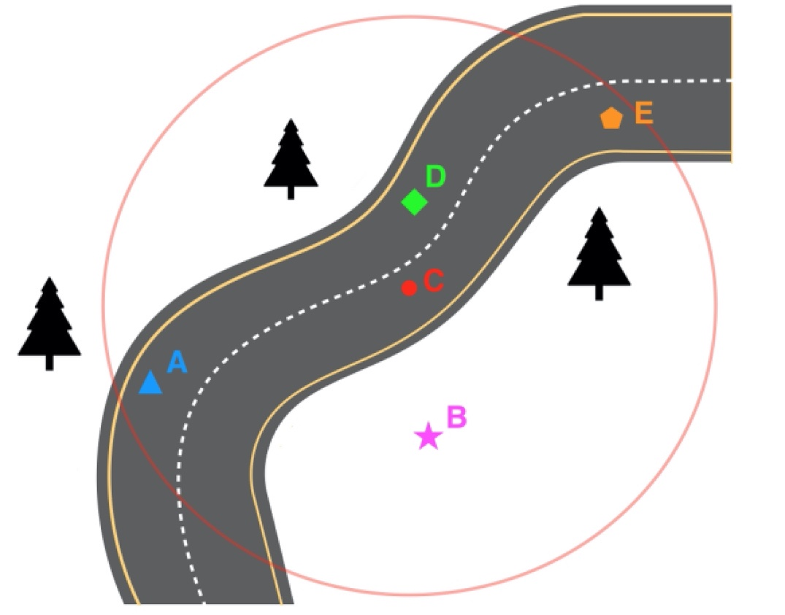

Road map with additional sensor data

**Learning Objectives - Bayes' Rule**

The following questions will help you review what you learned in the Bayes' Rule lesson.

**Prior knowledge**

**For questions 1-3, assume you already have the following knowledge**:

You’re interested in finding out the probability of a car stopping if it sees a *yellow* traffic light.

* Past data tells you that the probability of a car stopping at a traffic light intersection is P(S) = 0.40  
  *P*(*S*)=0.40.
* You also know that the past probability of a traffic light being yellow (as opposed to red or green) is P(Y) = 0.10  
  *P*(*Y*)=0.10.

## Step by Step Walkthrough

The step-by-step breakdown of the solution is pretty quick. Let's recap what's covered in the solution video.

Let's start with what we know:

#### Prior Probabilities

The robot is perfectly ignorant about where it is, so prior probabilities are as follows:

P(\text{at red} ) = 0.5*P*(at red)=0.5

P(\text{at green} ) = 0.5*P*(at green)=0.5

#### Conditional Probabilities

The robot's sensors are not perfect. Just because the robot sees red does **not** mean the robot is at red.

P(\text{see red} | \text{at red} ) = 0.8*P*(see red∣at red)=0.8

P(\text{see green} | \text{at green} ) = 0.8*P*(see green∣at green)=0.8

#### Posterior Probabilities

From these prior and posterior probabilities we are asked to calculate the following posterior probabilities after the robot sees red:

1. P(\text{at red} | \text{see red} )*P*(at red∣see red)
2. P(\text{at green} | \text{see red} )*P*(at green∣see red)

and as a reminder, Bayes' rule looks like this:

P(A|B ) = \frac{P(B|A) \cdot P(A)}{P(B)}*P*(*A*∣*B*)=*P*(*B*)*P*(*B*∣*A*)⋅*P*(*A*)​

or, if we want to use our "versions" of A and B (for posterior #1)...

P(\text{at red}|\text{see red} ) = \frac{P(\text{see red}|\text{at red}) \cdot P(\text{at red})}{P(\text{see red})}*P*(at red∣see red)=*P*(see red)*P*(see red∣at red)⋅*P*(at red)​

Now, we can read two of those terms from what we already know about our prior and conditional probabilities which means we can rewrite this as...

P(\text{at red}|\text{see red} ) = \frac{0.8 \cdot 0.5}{P(\text{see red})}*P*(at red∣see red)=*P*(see red)0.8⋅0.5​

But we still have one unknown! What was the probability that we would see red? The answer is 0.5 and there are two ways I can convince myself of that. The first is intuitive and the second is mathematical.

#### Why is P(see red) 0.5?

##### Argument 1: Intuitive

Of course it's 0.5! What else could it be? The robot had a 50% belief that it was in red and a 50% belief that it was in green. Sure, its sensors are unreliable but that unreliability is symmetric and **not** biased towards mistakenly seeing either color.

So whatever the probability of seeing red is, that will also be the probability of seeing green. Since these two colors are the only possible colors the probability MUST be 50% for each!

##### Argument 2: Mathematical (Law of Total Probability)

There are exactly two situations where the robot would see red.

1. When the robot is in a red square and its sensors work correctly.
2. When the robot is in a green square and its sensors make a mistake.

I just need to add up these two probabilities to get the total probability of seeing red.

P(\text{see red} ) = P(\text{at red}) \cdot P(\text{see red} | \text{at red}) + P(\text{at green}) \cdot P(\text{see red} | \text{at green})*P*(see red)=*P*(at red)⋅*P*(see red∣at red)+*P*(at green)⋅*P*(see red∣at green)

I can read these quantities from above!

P(\text{see red} ) = 0.5 \cdot 0.8 + 0.5 \cdot 0.2*P*(see red)=0.5⋅0.8+0.5⋅0.2

P(\text{see red} ) = 0.4 + 0.1*P*(see red)=0.4+0.1

P(\text{see red} ) = 0.5*P*(see red)=0.5